Health Equity Now for
Immigrants, Migrants, and Refugees
Special Double Panel Session – APHA 2018 Annual Meeting
Tues., Nov. 13, 2018
PART 1: 3-4:30pm
PART 2: 5-6:30pm
Hilton San Diego Bayfront – Aqua 309, San Diego, CA

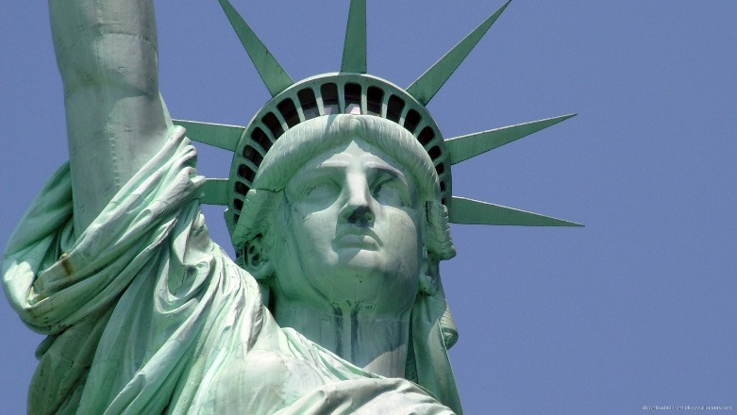
In these times, immigrants, migrants, and refugees are among the most vulnerable populations in the US and elsewhere. How can we reduce health disparities among immigrants, migrants, and refugees? What are providers doing to advance health equity and justice for immigrants, migrants, and refugees?
Join us for special presentations by some of the leading voices in the field.

Presentations and Speakers: Part 1

Advancing Health Equity for Refugee Women: Experience of a Dedicated Refugee Women’s Health Clinic in a Health Care Safety Net System in Arizona.
Presenter: Crista E Johnson-Agbakwu, MD, MSc, FACOG

La Clínica del Pueblo: Working to make health care a human right in Washington, DC and
Prince George’s County, MD.
Presenter: Suyanna Barker, DrSc

Family and School Connectedness Associated with Lower Depression among Latino Early Adolescents in an Agricultural County. Presenter: Marissa Raymond-Flesch, MD, MPH

Criminalizing state policies and health care inequalities: an examination of noncitizens’ access to care across states.
Presenter: Maria-Elena De Trinidad Young, MPH
Presentations and Speakers: Part 2

Role of "Sanctuary" Policies in Advocating for Immigrant Health.
Presenter: Altaf Saadi, MD, MSHPM

Immigration, Acculturation, and Multimorbidity among Hispanic adults in the United States.
Presenter: Jacquelyn McRae, PharmD

Stakeholder perspectives on needs and resources for immigrants with chronic conditions during transitions from hospital to home care.
Presenter: Wendy Camelo Castillo, MD MSc PhD

Everyday Discrimination and Healthcare Seeking Behaviors among Saudis Living in the U.S.
Presenter: Tassnym Sinky, PhD, MPH

